Faculty of Mechanical Engineering

Technion – Israel Institute of Technology

Final CAD Project

IGES to STL file conversion program

Elias Cohenca
Student Number: 015257231

Mentor:
Ronit Schneor

Winter 2007

Introduction 3
About the IGES format 6
About the STL format 7
Existing programs 8
Program Description 8
Technical Information 11
Program Flow Overview 11

- Introduction

  - Motivation

This project was started as a request from the company Objet (http://www.2objet.com), manufacturer of rapid-prototyping machines (“3D Printers”), to create a GUI-based program to translate an IGES version 5 file (Initial Graphics Exchange Specification) to an STL file (Stereolithography). The need for this program derives from their 3D printers’ software, which uses the STL format as their source, and from the fact that the IGES format is a very popular format, which has been around since the beginning of the 1980's.
3D Printers work by deposition of layer upon layer, where each layer is a cross-section of the model, and the material used is a fine powder or a polymer that can be selectively “printed”, akin to an inkjet printer. For this reason, the printed model is a discrete approximation of the original CAD model, which is usually defined as parametric surfaces. That’s why the STL file, which is a list of triangles defining the different surfaces, is the preferred file for these printers (and as its name implies, it was originally created for this type of machines), because the triangles form a mesh that is reproducible by a discrete production method such as these printers.

  - Project Definition

The program can open files that were saved according to the IGES v5 specification. IGES comes in many flavors. It can be used to describe a wireframe, a circuit diagram or a solid model, among others. Being that this program converts IGES models to be used on a 3D printer, only solid models are supported, and more specifically, models saved as Trimmed Surfaces. It then performs internal corrections in the model (if needed) and lets the user select relevant options for the conversion. Finally, the user can save the result as an STL file.
Since IGES saves the model information as parametric surfaces, this means that the quality of the conversion will depend on the way we draw these surfaces, meaning, the level of detail we choose for the triangulation. The program lets the user select the tolerance levels that will determine the quality of the final model, as well as the method used to approximate the conversion to the original surface.

  - Literature

- The Initial Graphics Exchange Specification (IGES) Version 5.0 NISTIR 4412 – September 1990.
- The NURBS Book. Piegl, L. & Tiller, W. Springer, 2nd Edition, 1997.
- The OpenGL Reference Manual – The Blue Book. http://www.glprogramming.com/blue/
- The OpenGL Programming Guide – The Red Book. http://glprogramming.com/red/

  - Existing Programs

Okino (http://www.okino.com/default.htm) sells a multipurpose converter, meaning that it is not possible to buy only an IGES converter, and its price starts at $640 (there are different versions of the base program, with more features added for a higher price – this price is for the basic program)
Wiz-Worx (http://www.wiz-worx.com/wizworx.htm) sells source code for reading IGES files for the sum of $5,000. This includes phone support.
Many professional CAD programs such as SolidWorks or ProE can import IGES files, and export to STL, so that they can be used as a conversor.

  - Known Problems

For the testing purposes of this program, IGES files as exported by SolidWorks were used. This led to the discovery of some problems in the exported files, which seem to be inherent to SolidWorks.
The first of these problems concern the direction of the surfaces. Since the direction (the normal) of the surface determines where the solid part of the model is (e.g. the material would be behind the surface), it is very important that the model maintains consistency among the normals in order for the 3D printer’s software to determine where it should inject the material. And the problem arises in that in almost every model exported from SolidWorks, some of the surfaces are reversed (we can see this when we choose to illuminate only front faces). To correct this, a manual system was added to the program which allows the user to reverse those surfaces. Even though we can easily see when a surface is not in its correct direction, an analytical solution is not a trivial task.
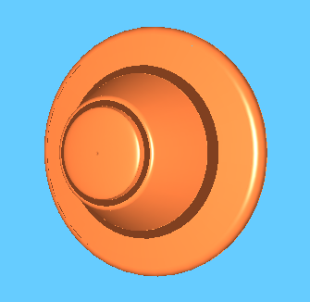
IGES as saved by SolidWorks. The darker strips are inverted surfaces

Another problem is related to the trimming lines. In order to trim a surface, the lines must form a closed loop. This way we can “cut” whatever’s inside the lines (or outside, determined by the direction of the loop). But in many SolidWorks files, the lines forming the loop aren’t completely closed. In most cases, the problem arises from the end point of one line being slightly off the begin point of the next one, but in other cases, a complete line is missing. A check was added to the program, where if the lines are apart by a distance closer than a tolerance value (changeable by the user), then they are joined by bringing one endpoint of a line to the previous one. But if the distance is larger, a straight line is added between them.
Yet another problem is related to the fact that the IGES format doesn’t save relational data between surfaces, such as who’s whose neighbor. This leads to difficulty during the tessellation of rounded parts, because the quality at the common border might be different between the two surfaces, leading to gaps in that area.
These problems will be explored in more detail later. They were found after extensive trial of different files, but by no means can we assume that they are the only problems. They are most certainly the prevalent ones. On the other hand, there are many other programs in the market that export IGES files, and since each developer has to adapt the IGES protocol to their own database, different problems can arise for each of these programs. This is why the companies selling IGES readers use their years of experience as their selling point. Or as Okino puts it in their website when describing their product: “This is a "surface based" IGES importer that has been under constant development at Okino since 1989 and hence it is "rock stable" - we know IGES like the back of our hands!”

- Theoretical Background

  - Geometric Representation

As stated in the introduction, the program supports IGES files that were saved as trimmed surfaces. They are defined by two components: the surface to be trimmed, and the trimming lines. The trimming lines themselves are differentiated by being boundary or internal lines. They can be defined in the Euclidean space or in the parametric space of the surface, although the latter is preferred (and it’s the method supported in the converter).
The parametric space definition means that if we map the surface to a two-dimensional plane, with axes u and v, its domain would be a bounded rectangle. This domain can be normalized so that u and v is bounded between 0 and 1. In this way the following point sequence: (0,0) → (1,0) → (1,1) → (0,1) → (0,0), defines the outer boundary.
The direction of the lines is also important: they define which side is trimmed. The rule is that whatever is found on the left side of the line remains, and anything on its right is trimmed away. Here’s an example:
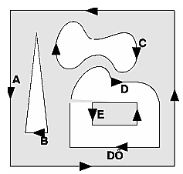
A is a boundary trim line. B, C, D are internal trim lines.
The specification defines what types of surface definition are supported, but we’ll concentrate on the two most important ones: NURBS and surface of revolution.

    - NURBS

Non-Uniform Rational B-Splines conform a very broad subject, which fills many books. We won’t go into the mathematical theory behind it, but nonetheless try to explain the basics.

About the IGES format

According to the IGES 5 reference bookthe IGES specification “establishes information structures to be used for the digital representation and communication of product definition data. Use of this Specification permits the compatible exchange of product definition data used by various CAD systems.”
The IGES project was started in 1979 by a group of CAD users and vendors, including Boeing, General Electric, Xerox, Computervision and Applicon, with the support of the National Bureau of Standards (now known as NIST) and the U.S. Department of Defense (DoD). The name was carefully chosen to avoid any suggestion of a database standard that would compete with the proprietary databases then used by the different CAD vendors.
An IGES file is composed of 80-character ASCII records, a record length derived from the punch card era. Text strings are represented in "Hollerith" format, the number of characters in the string, followed by the letter "H", followed by the text string, e.g., "4HSLOT".
The file is divided into 5 Sections, indicated by a character (S, G, D, P, or T) in column 73. The characteristics and geometric information for an entity is split between two sections; one in a two record, fixed-length format (the Directory Entry, or DE Section), the other in a multiple record, comma delimited format (the Parameter Data, or PD Section).
The first section S (for Start) is designed to provide a human-readable prologue to the file.
The second section G (for Global) contains information for the preprocessor, such as which character to use as the delimiter between data (the default being a comma) and between records (the default being a semicolon). There are 25 different entries in this section, ranging from the filename to the date of creation, but most are irrelevant for conversion to an STL file.
The third and fourth section are the core of the format, the data itself. As stated before, this is divided into directory entries (section D), and the parameter associated with these entries (section P). The types of different entries are called entities and they are numerated in the IGES specification. For example, a B-spline curve is type 126. There is an hierarchical relationship between entities which will be explored later.
The last section, T (for Terminate) is only one line, and must be the last line in the file. It contains a summary of the number of lines present in each section.
More information regarding the structure of the file can be found later on in the description of the program’s database.

Example of an IGES file depicting a rational b-spline surface (type 128)
1H,,1H;,7H128-000,11H128-000.IGS,9H{unknown},9H{unknown},16,6,15,13,15, G 1
7H128-000,1.,1,4HINCH,8,0.016,15H19970830.165254,0.0001,0., G 2
21Hdennette@wiz-worx.com,23HLegacy PDD AP Committee,11,3, G 3
13H920717.080000,23HMIL-PRF-28000B0,CLASS 1; G 4
128 1 0 1 0 0 0 000000001D 1
128 0 2 17 0 D 2
128,3,7,3,5,0,0,1,0,0,0.,0.,0.,0.,1.,1.,1.,1.,0.,0.,0.,0.,0.,0., 1P 1
1.,2.,3.,3.,3.,3.,3.,3.,1.,1.,1.,1.,1.,1.,1.,1.,1.,1.,1.,1.,1., 1P 2
1.,1.,1.,1.,1.,1.,1.,1.,1.,1.,1.,1.,1.,1.,1.,1.,1.,1.,1.,8.5, 1P 3
9.5,1.,8.5,9.25,0.666667,8.5,9.,0.333333,8.5,8.75,0.,8.49394, 1P 4
9.446590000000001,1.,8.49394,9.196590000000001,0.666667,8.49394, 1P 5
8.946590000000001,0.333333,8.49394,8.696590000000001,0., 1P 6
8.436360000000001,9.39545,1.,8.436360000000001,9.14546,0.666667, 1P 7
8.436360000000001,8.89545,0.333333,8.436360000000001,8.64545,0., 1P 8
8.21364,9.485799999999999,1.,8.21364,9.235799999999999,0.666667, 1P 9
8.21364,8.985799999999999,0.333333,8.21364,8.735799999999999,0., 1P 10
7.78636,9.82671,1.,7.78637,9.57671,0.666667,7.78637,9.32671, 1P 11
0.333333,7.78636,9.07671,0.,7.56363,9.804539999999999,1., 1P 12
7.56363,9.554539999999999,0.666667,7.56363,9.304539999999999, 1P 13
0.333333,7.56363,9.054539999999999,0.,7.50606,9.628410000000001, 1P 14
1.,7.50606,9.378410000000001,0.666667,7.50606,9.128410000000001, 1P 15
0.333333,7.50606,8.878410000000001,0.,7.5,9.5,1.,7.5,9.25, 1P 16
0.666667,7.5,9.,0.333333,7.5,8.75,0.,0.,1.,0.,3.; 1P 17
S 1G 4D 2P 17 T 1

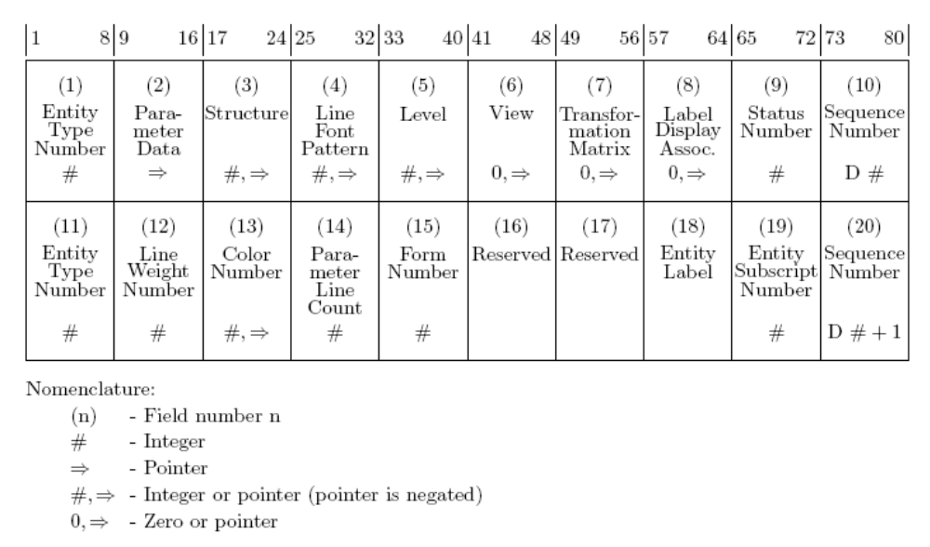

Format of the Directory Entry (DE) Section

  - About the STL format

STL is a file format native to the stereolithography CAD software created by 3D Systems. This file format is supported by many other software packages; it is widely used for rapid prototyping and computer-aided manufacturing. STL files describe only the surface geometry of a three dimensional object without any representation of color, texture or other common CAD model attributes.
The file begins with the line:

solid name

where name is an optional string.
The file then continues with a list of triangles, and their respective normals. The format is:

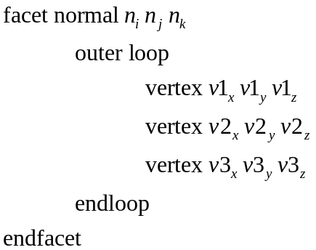

The normal is actually redundant, since it can be computed from the triangle itself by cross multiplying, but it should be added since some programs use it as a consistency check.
The file ends with the line:

endsolid name

The structure of the format suggests that other possibilities exist (e.g. facets with more than one 'loop' or loops with other than three vertices) but in practice, all facets are simple triangles.

  - Existing programs

- Program Description

To understand the working and the structure of the program, a more thorough explanation of an IGES file and its entities is needed.
The type of IGES supported by this program is Trimmed Surface (type 144). This means that each surface in the original model is saved as a separate surface, with outer and inner boundaries that define trimming lines. Any part of the surface outside the outer boundary will be trimmed away, and any part of the surface inside the inner boundaries will be cut and discarded. Each and any surface can have only one outer boundary, and as many inner boundaries as desired.
The trimmed surface depends on other entities for its definition, and these entities themselves also depend upon others. The hierarchy is shown here:

144 – Trimmed Surface
128 – Rational B-Spline Surface
Or
120 – Surface of Revolution

142 – Curve on a Parametric Surface

Surface Definition
Outer and Inner Boundaries
102 – Composite Curve
(Defined in surface’s parametric space)

126 – B-Spline Curve
(As many as defined by the composite curve entity)

102 – Composite Curve
(Defined in Euclidean space)

110 – Line Entity
100 – Arc Entity
(As many as defined by the composite curve entity)

In case a Surface of Revolution (type 120) is used it is defined by the following entities:
120 – Surface of Revolution

110 – Line Entity

110 – Line Entity
100 – Arc Entity
(only one of them)

Axis of Revolution
Generatrix Entity

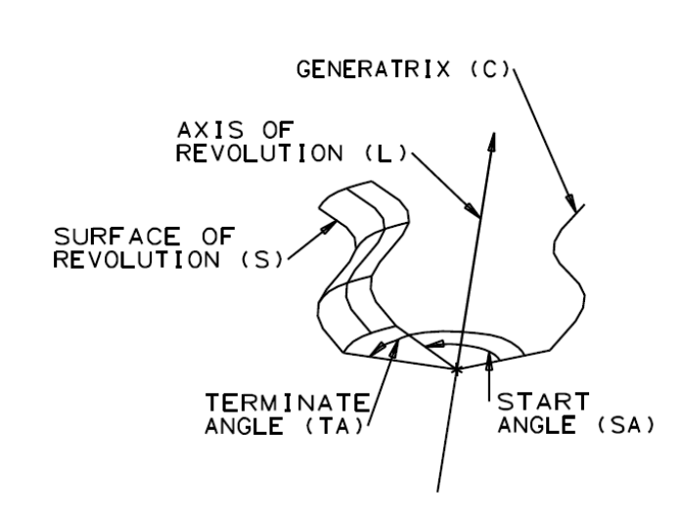
It is important to note that the hierarchy previously discussed is created only when saving the IGES file as a Trimmed Surface, and that there are many other systems that the IGES specification permits which are not supported by this program. Furthermore, some programs (such as SolidWorks) allow the selection of different representations.

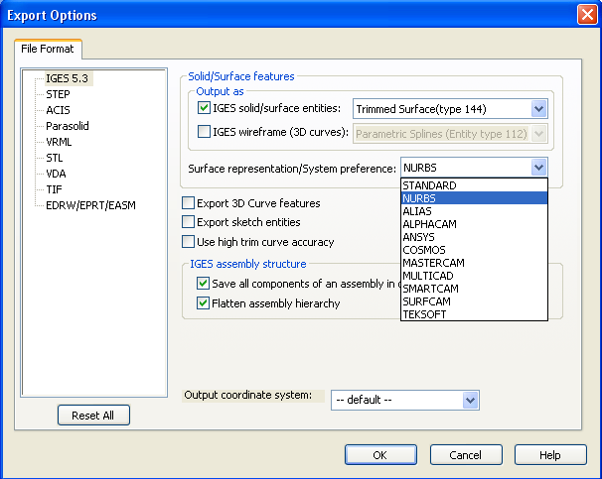
SolidWorks' Export to IGES options window
The preferred representation is NURBS, in which every single surface is saved as a Non-Uniform Rational B-Spline surface. The other supported representation is STANDARD, in which surfaces are saved as either NURBS or as Surfaces of Revolution. This method is less preferred since it usually gives less precise results, being that we are mixing different types of surface definitions.

Technical Information

The program was written in C++ using Visual Studio 2005. The main libraries used were OpenGL and MFC. The Document/View architecture was used within an SDI (Single Document Interface).

Program Flow Overview

OpenGL provides functions to draw non-rational b-splines curves and surfaces. Because of the discrete nature of computer graphics, NURBS (which are parametric) have to be converted to a mesh of polygons in order to be displayed on screen. This process is called “Tessellation”. Thus, in the following GL-produced image:

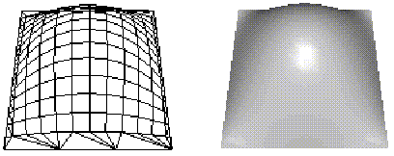

the image on the left is the mesh representation of a b-spline surface, and the image on the right is the same mesh using illumination to better give the appearance of being a continuous surface.
Since, as stated before, the surfaces in an IGES file are saved (preferably) as NURBS surfaces, we could draw them through OpenGL, capture the converted mesh and transform it to a triangle list, thus effectively converting the IGES file into an STL file.
In order to do this OpenGL provides us with a few functions. First and foremost, we have to specify that we don’t want the surface to be rendered to the screen, but to send the tessellation to Callback functions, so that we can decide what to do with the information. We do this with the following command, when initializing the program:

gluNurbsProperty(nurb, GLU_NURBS_MODE, GLU_NURBS_TESSELLATOR);

where nurb is a GL NURBS object.
Next we define the Callback functions. These are simply overrides for the OpenGL basic functions, such as glBegin, glVertex, glEnd. As can be seen in the previous image, the mesh is composed of quad strips and triangle fans. When the NURBS renderer draws these polygons, it issues a series of commands to draw them in the same vein as a simple drawing program. For example:

glBegin(GL_QUAD_STRIP) //Draws a rectangle
glVertex3fv(v1)
glVertex3fv(v2)
glVertex3fv(v3)
glVertex3fv(v4)
glEnd()

The overridden callback functions save all this information (the type of polygon, when it begins and ends, and the vertices) in a structure defined within the program.
The quad strips and triangle fans previously mentioned are defined as follows:
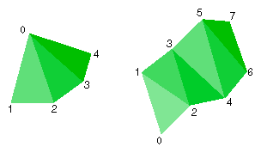
So the next step to obtain an STL is to read the information and convert the quad strips and triangle fans into independent triangles.
As can be expected from the conversion of a parametric figure into a discrete mesh, the size of the tessellated polygons will affect the quality of the resulting image in the STL file. OpenGL offers three different modes of creating the mesh, by changing the NurbsProperty GLU_SAMPLING_METHOD :

GLU_OBJECT_PARAMETRIC_ERROR: specifies that the surface is rendered in such a way that the value specified by GLU_PARAMETRIC_TOLERANCE describes the maximum distance, in object space, between the tessellation polygons and the surfaces they approximate.

GLU_OBJECT_PATH_LENGTH: the surface is rendered so that the maximum length, in object space, of the edges of the tessellation polygons is no greater than what is specified by GLU_SAMPLING_TOLERANCE.

GLU_DOMAIN_DISTANCE: allows users to specify, in parametric coordinates, how many sample points per unit length are taken in u,v direction, specified by GLU_U_STEP and GLU_V_STEP.

All these parameters can be changed through the user interface, as will be explained later, to achieve the desired results.
What happens in the case that an IGES surface is not defined from the beginning as a NURBS? A
IGES file is loaded

IGES - Wikipedia http://en.wikipedia.org/wiki/IGES
STL – Wikipedia http://en.wikipedia.org/wiki/STL_%28file_format%29

